**ABOUT THE COMPANY**

IC Solution (ICS) is a digital service provider that aims to provide software, designing and marketing solutions to individuals and businesses. At ICS, we believe that service and quality is the key to success

We provide all kinds of technological and designing solutions from Billing Software to Web Designs or any custom demand that you may have. Experience the service like none other!

Some of our services include:

Development - We develop responsive, functional and super-fast websites.

We keep User Experience in mind while creating websites. A website should load quickly and should be accessible even on a small view-port and slow internet connection.

Mobile Application - We offer a wide range of professional Android, iOS & Hybrid app development services for our global clients, from a startup to a large enterprise.

Design - We offer professional Graphic design, Brochure design & Logo design. We are experts in crafting visual content to convey the right message to the customers.

Consultancy - We are here to provide you with expert advice on your design and development requirement.

Videos - We create a polished professional video that impresses your audience.

**TABLE OF CONTENTS**

|  |  |  |
| --- | --- | --- |
| SL.NO | CONTENTS | PAGE-NO |
| 1 | OVERVIEW OF THE PROJECT | 3 |
| 2 | ABOUT EOTO | 3 |
| 3 | ADVANTAGES AND CHALLENGES | 4 |
| 4 | TOOLS USED | 5 |
| 5 | IMPLAMENTATION | 6 |
| 6 | SNAPSHORTS | 14 |

## OVERVIEW OF THE PROJECT

## The “Each One Teach One” web pages created for seeking education each other. This web page consist of home page with short description of EOTO and two buttons one for the pupil on click redirects to pupil registration and another one for educator on click redirects to educator registration and thank you page. And it also consist of about page with brief description at last contact page.

## ABOUT EOTO

Each One Teach One is a simple technique for imparting small pieces of understanding to a group—one student at a time. Each student confronts new information, learns it, and then is empowered to teach it to each other student. It allows the student to understand better and provides the learner with rare one-on-one attention and lets students select “lessons/Modules” appropriate to particular student learning styles, energy levels, and personalities. As a teaching method, it can be used with almost any subject. This helps the individual to enhance the understanding of self and the subject, as unofficially proven, it is always.that best friend who becomes the best teacher by teaching topics in a way that one can remember in the last minute, EOTO would be taking this concept much farther by building the system for it, with a community that would work for the betterment of the concept and the idea, includes analysis, maintenance, support, improvement, etc.(ADD some more info)

## ADVANTAGES AND CHALLENGES

## “EACH ONE AND TEACH ONE” is the technique of teaching where exchange of knowledge occurs frequently so this website helps in the website.

## It is very important to spread the technique because reaching each and every one in the country is very essential to spread knowledge

## goal is part of an initiative that was launched in the capital yesterday. Called 300M - or the 300 Million Challenge - it seeks to draw thousands of young boys and girls into education by making learning fun.

## Here there is a opportunity for teaching and also learning frequently, the knowledge person can teach as well as he can learn so it is well advantages.

**Tools Used:**

* **Hardware Requirements:**

**Processor :** Intel Core i7

**Memory :** 4GB RAM

**Keyboard :** QWERTY

* **Software Requirements:**

**Operating System:** Windows10

**Tools :** Visual Studio Code 2020, Chrome

**Languages :** HTML, CSS, JAVA Script

# IMPLEMENTATION

**Source Code:**

Code for Index.html

 <html>

<head>

  <title>Each One Teach One</title>

  <meta charset="utf-8">

    <link rel="stylesheet" type="text/css" href="css/index.css">

</head>

 <body>

  <section class="showcase">

    <header>

      <h2 class="logo">EOTO</h2>

      <div class="toggle"></div>

    </header>

    <video src="video/1.mp4" muted loop autoplay></video>

    <div class="overlay"></div>

    <div class="text">

      <h2>Each one Teach one</h2>

      <p>Each One Teach One is a simple technique for imparting small pieces of understanding to a

        group—one student at a time. Each student confronts new information, learns it, and then is

        empowered to teach it to each other student. It allows the student to understand better and

        provides the learner with rare one-on-one attention and lets students select

        “lessons/Modules” appropriate to particular student learning styles, energy levels, and

        personalities.</p>

        <h3>” If you are a student and willing to learn, Click here”<a href="pupil.html">pupil</a></h3>

        <h3>”If you are a student and willing to teach, Click here”<a href="educator.html">educator</a></h3></div

    <ul class="social">

      <li><a href="https://www.facebook.com/"><img src="https://i.ibb.co/x7P24fL/facebook.png"></a></li>

      <li><a href="https://twitter.com/"><img src="https://i.ibb.co/Wnxq2Nq/twitter.png"></a></li>

      <li><a href="https://www.instagram.com/"><img src="https://i.ibb.co/ySwtH4B/instagram.png"></a></li>

    </ul></section>

  <div class="menu">

    <ul>

      <li><a href="index.html">Home</a></li>

      <li><a href="about.html">About</a></li>

      <li><a href="contactus.html">Contact Us</a></li>

    </ul>

  </div>

  <script>

       const menuToggle = document.querySelector('.toggle');

      const showcase = document.querySelector('.showcase');

      menuToggle.addEventListener('click', () => {

        menuToggle.classList.toggle('active');

        showcase.classList.toggle('active');

      })

  </script>

 </body>

  </html>

Code for Index.css

@import url('https://fonts.googleapis.com/css?family=Poppins:200,300,400,500,600,700,800,900&display=swap');

*

{

  margin: 0;

  padding: 0;

  box-sizing: border-box;

  font-family: 'Poppins', sans-serif;

}

header

{

  position: absolute;

  top: 0;

  left: 0;

  width: 100%;

  padding: 40px 100px;

  z-index: 1000;

  display: flex;

  justify-content: space-between;

  align-items: center;

}

header .logo

{

  color: #fff;

  text-transform: uppercase;

  cursor: pointer;

}

.toggle

{

  position: relative;

  width: 60px;

  height: 60px;

  background: url(https://i.ibb.co/HrfVRcx/menu.png);

  background-repeat: no-repeat;

  background-size: 30px;

  background-position: center;

  cursor: pointer;

}

.toggle.active

{

  background: url(https://i.ibb.co/rt3HybH/close.png);

  background-repeat: no-repeat;

  background-size: 25px;

  background-position: center;

  cursor: pointer;

}

.showcase

{

  position: absolute;

  right: 0;

  width: 100%;

  min-height: 100vh;

  padding: 100px;

  display: flex;

  justify-content: space-between;

  align-items: center;

  background: #111;

  transition: 0.5s;

  z-index: 2;

}

.showcase.active

{

  right: 300px;

}

.showcase video

{

  position: absolute;

  top: 0;

  left: 0;

  width: 100%;

  height: 100%;

  object-fit: cover;

  opacity: 0.8;

}

.overlay

{

  position: absolute;

  top: 0;

  left: 0;

  width: 100%;

  height: 100%;

  background: #595a5a;

  mix-blend-mode: overlay;

}

.text

{

  position: relative;

  z-index: 10;

}

.text h2

{

  font-size: 3.5em;

  font-weight: 800;

  color:  rgb(136, 211, 255);

  line-height: 1em;

  text-transform: uppercase;

}

.text p

{

  font-size: 1.4em;

  color: rgb(255, 255, 255);

  margin: 20px 0;

  font-weight: 400;

  max-width: 700px;

}

.text h3

{

  font-size: 1.1em;

  font-weight: 700;

  color: #fff;

  line-height: 1em;

  text-transform: uppercase;

}

.text a

{

  display: inline-block;

  font-size: 1.6em;

  background:transparent;

  padding: 10px 30px;

  text-transform: uppercase;

  text-decoration: none;

  font-weight: 500;

  margin-top: 10px;

  color:  rgb(136, 211, 255);

  letter-spacing: 2px;

  transition: 0.2s;

}

.text a:hover

{

  letter-spacing: 6px;

}

.social

{

  position: absolute;

  z-index: 10;

  bottom: 20px;

  display: flex;

  justify-content: center;

  align-items: center;

}

.social li

{

  list-style: none;

}

.social li a

{

  display: inline-block;

  margin-right: 20px;

  filter: invert(1);

  transform: scale(0.5);

  transition: 0.5s;

}

.social li a:hover

{

  transform: scale(0.5) translateY(-15px);

}

.menu

{

  position: absolute;

  top: 0;

  right: 0;

  width: 300px;

  height: 100%;

  display: flex;

  justify-content: center;

  align-items: center;

}

.menu ul

{

  position: relative;

}

.menu ul li

{

  list-style: none;

}

.menu ul li a

{

  text-decoration: none;

  font-size: 24px;

  color: #111;

}

.menu ul li a:hover

{

  color: #03a9f4;

}

@media (max-width: 991px)

{

  .showcase,

  .showcase header

  {

    padding: 40px;

  }

  .text h2

  {

    font-size: 3em;

  }

  .text h3

  {

    font-size: 2em;

  }

}

/* contact us */

body{

  padding: 0px;

  margin: 0px;

  font-family: sans-serif;

  overflow: hidden;

 }

.container{

 position: fixed;

 right: 0;

 width: 100%;

 height: 100%;

 min-height: 100vh;

 padding: 100px;

 background-image:url("/images/1.png");

 background-repeat: no-repeat;

 background-position: center;

 background-size: cover;

 align-items: center;

}

  #contact-section{

    font-size: 2em;

    background: linear-gradient(rgba(0,0,0,0.6),rgba(0,0,0,0.9));

    background-size: cover;

    background-position: center;

    height: 100%;

    width: 100% ;

    padding-bottom: 2%;

  }

  #contact-section .container h2{

    text-align: center;

    text-decoration: underline;

    text-underline-position: under;

    color: rgb(28, 72, 80);

    letter-spacing: 2px;

  }

  #contact-section .container p{

    text-align: center;

    width: 70%;

    margin-left: auto;

    margin-right: auto;

    padding-bottom: 3%;

    color: rgb(31, 31, 31);

    letter-spacing:3px;

  }

  .contact-form i.fa{

    font-size: 22px;

    padding: 3%;

    background-color: none;

    border-radius: 80%;

    margin: 2%;

    cursor: pointer;

    border:2px solid rgb(85, 82, 82);

    color: rgb(117, 114, 114);

  }

  .contact-form i.fa:hover{

    cursor: pointer;

    border:2px solid white;

    color: white;

  }

    .contact-form{

      display: grid;

      grid-template-columns: auto auto;

       }

    .form-info{

      font-size: 16px;

      font-style: italic;

      color: white;

      letter-spacing: 2px;

    }

    input{

      padding: 10px;

      margin:10px;

      width: 70%;

      background-color:rgba(115, 145, 142, 0.699);

      color: white;

      border: none;

      outline:none;

    }

    input::placeholder{

      color: white;

    }

     textarea{

    padding: 10px;

    margin: 10px;

    width: 70%;

    background-color:rgba(175, 175, 175, 0.5);

    color: white;

    border: none;

    outline:none;

   }

   textarea::placeholder{

     color: white;

   }

    .submit{

    width: 40%;

    background: none;

    padding: 4px;

    outline: none;

    font-size: 13px;

    font-weight: bold;

    letter-spacing: 2px;

    height: 33px;

    text-align: center;

    cursor: pointer;

    letter-spacing: 2px;

    margin-left: 15%;

    border:2px solid rgb(0, 0, 0);

    color: rgb(12, 12, 12);

   }

   .submit:hover{

         border: 3px solid rgb(0, 0, 0);

    color: rgb(28, 72, 80);

    cursor: pointer;

   }

      /* media queries */

  @media (max-width: 768px){

#contact-section .contact-form{

      display: block;

      width: 100%;

      text-align: center;

    }

    #contact-section .submit{

      width: 60%;

    }

}

Code for ABOUT.HTML

<html lang="en">

    <head>

        <meta charset="UTF-8">

        <title>About</title>

        <link rel="stylesheet" href="css/about.css">

    </head>

    <body>

        <div class="about-section">

            <div class="inner-container">

                <h1>About Us</h1>

                <p class="text"><b>

                    Each One Teach One is a simple technique for imparting small pieces of understanding to a

                    group—one student at a time. Each student confronts new information, learns it, and then is

                    empowered to teach it to each other student.<br>

                    It allows the student to understand better and provides the learner with rare one-on-one attention and lets students select

                    “lessons/Modules” appropriate to particular student learning styles, energy levels, and

                    personalities.<br>

                    As a teaching method, it can be used with almost any subject. This helps the

                    individual to enhance the understanding of self and the subject, as unofficially proven, it is always

                    that best friend who becomes the best teacher by teaching topics in a way that one can remember

                    in the last minute, EOTO would be taking this concept much farther by building the system for it,

                    with a community that would work for the betterment of the concept and the idea, includes

                    analysis, maintenance, support, improvement, etc.</b>

                </p>

            </div>

        </div>    </body></html>

Code for ABOUT.CSS

*{

    margin: 0;

    padding: 0;

    font-family: "Open Sans",sans-serif;

    box-sizing: border-box;

    overflow: hidden;

}

body{

    min-height: 100vh;

    display: flex;

    align-items: center;

    justify-content: center;

    background-color: #f1f1f1;

}

.about-section{

    background: url(/images/3.png) no-repeat left;

    background-size: 55%;

    background-color: #fdfdfd;

    overflow: hidden;

    padding: 100px 0;

}

.inner-container{

    width: 55%;

    float: right;

    background-color: #fdfdfd;

    padding: 150px;

}

.inner-container h1{

    margin-bottom: 30px;

    font-size: 30px;

    font-weight: 900;

}

.text{

    font-size: 25px;

    color: #000000;

    line-height: 200%;

    text-align: justify;

    margin-bottom: 40px;

}

@media screen and (max-width:1200px){

    .inner-container{

        padding: 80px;

    }

}

@media screen and (max-width:1000px){

    .about-section{

        background-size: 100%;

        padding: 100px 40px;

    }

    .inner-container{

        width: 100%;}

@media screen and (max-width:600px){     .about-section{

        padding: 0;

    }

    .inner-container{

        padding: 60px;}}

**SNAPSHOTS**

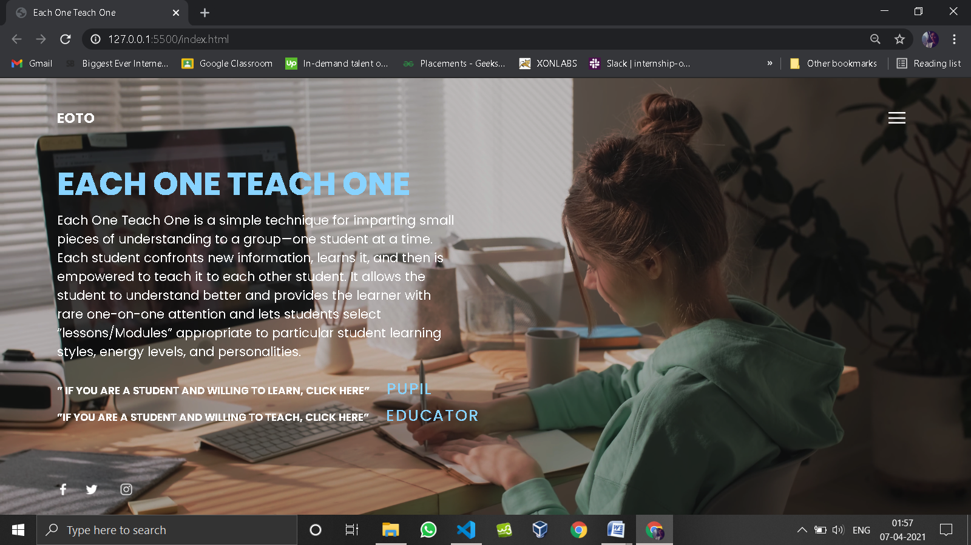

**FIG 1: Index page**

This is the index page which consist of short description of EOTO and two button which will redirect to pupil and educator page with video background.

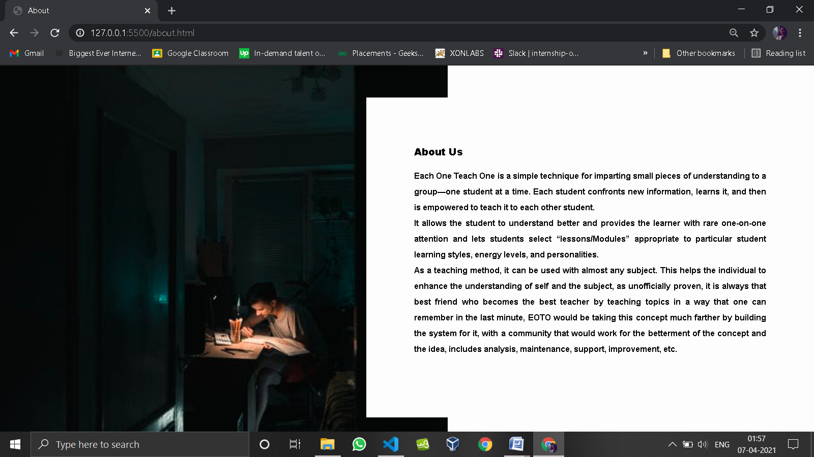

**FIG 2: About page**

About page consisting of brief description of EOTO.

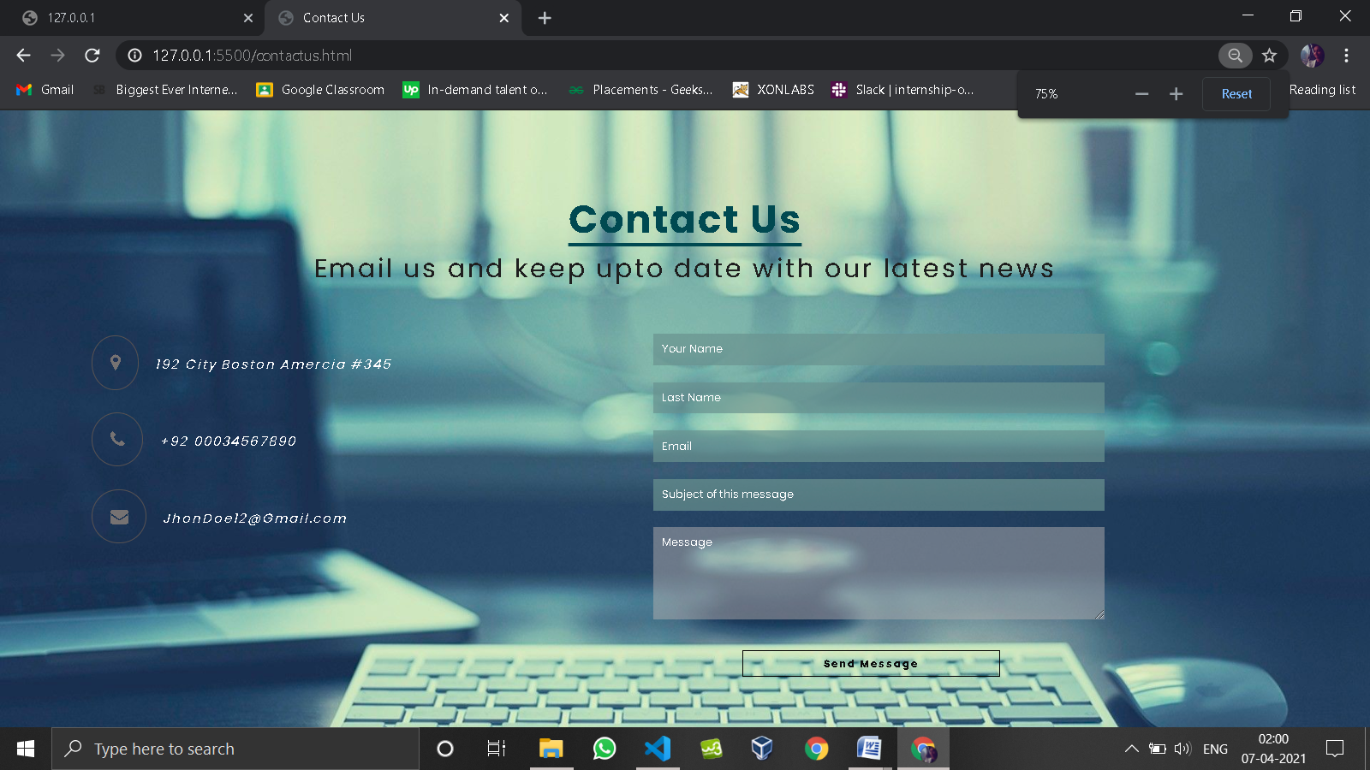

**FIG 3: Contact Us page**

This page consist of form were user have to input name, email and message and ask there queries.

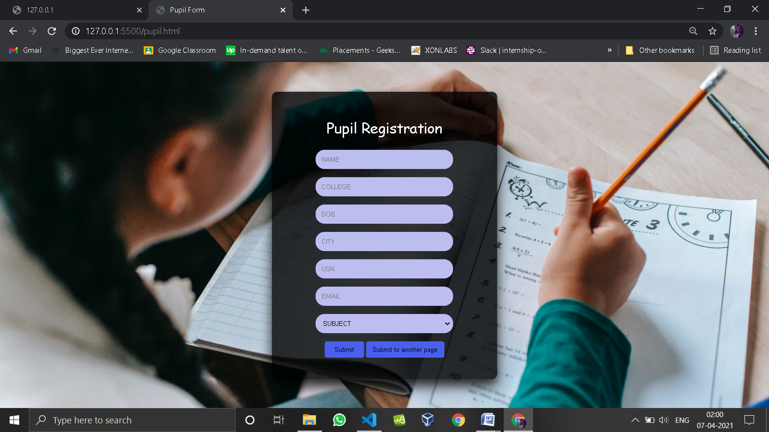

**FIG 4: Pupil registration page**

Here it includes form for student to register for the site providing there credentials.

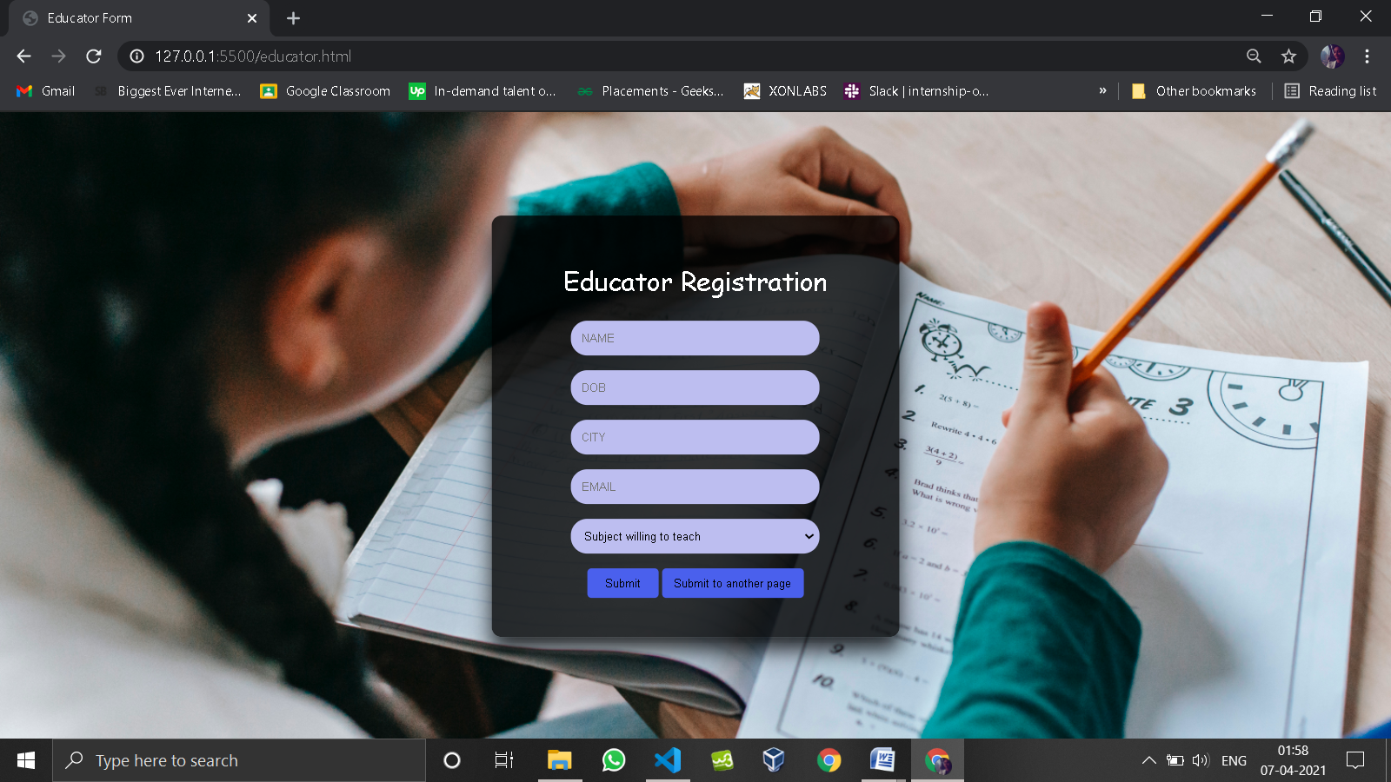

**FIG 5: Educator registration page**

Here it includes form for educator to register for the site providing there credentials.

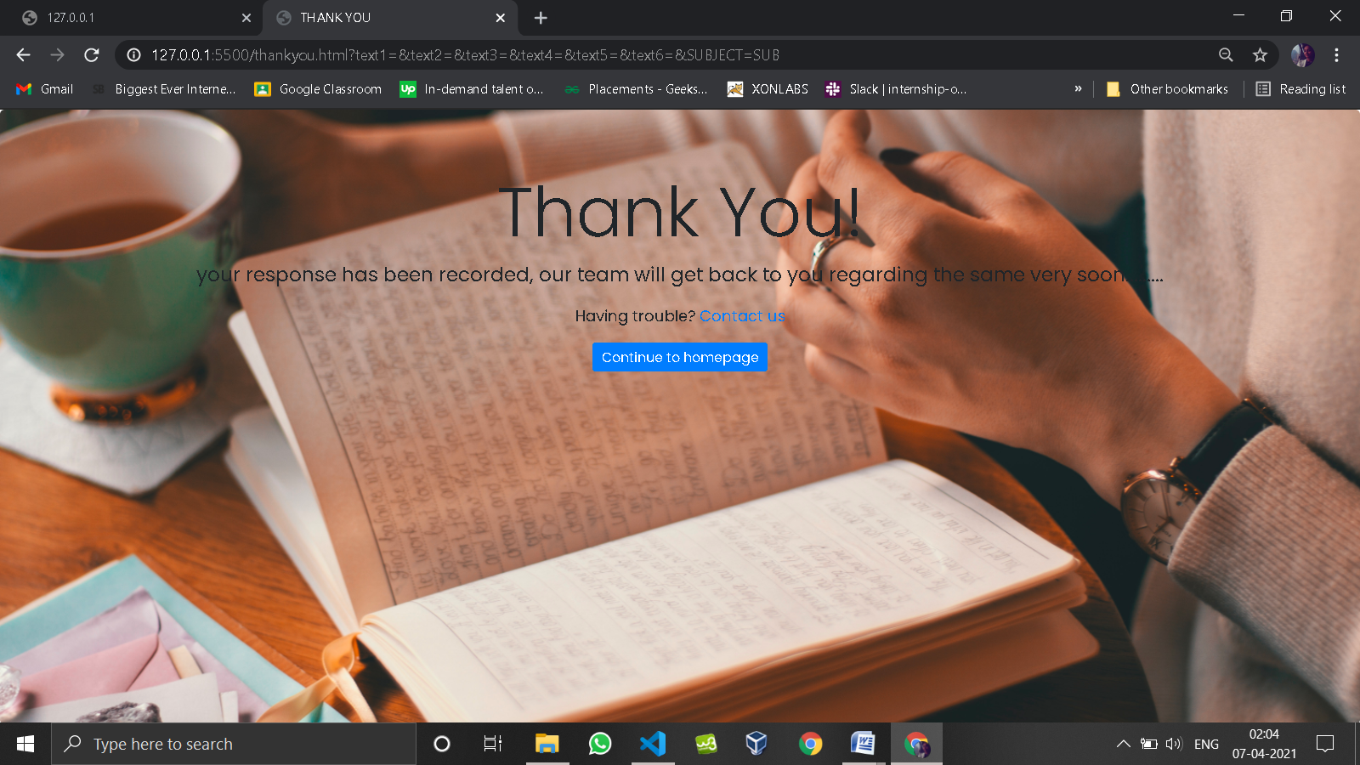

**FIG 6: Thank you page**

This is the page which provides message to the user

**BIBLIOGRAPHY**

* https://[www.w3schools.com](http://www.w3schools.com/)
* https://[www.geeksforgeeks.org](http://www.geeksforgeeks.org/)
* https://freefrontend.com